**Project Charter Template**

This Project Management Plan Template is free for you to copy and use on your project

and within your organization. We hope that you find this template useful and

welcome your comments. Public distribution of this document is only permitted

from the Project Management Docs official website at:

[ProjectManagementDocs.com](http://www.projectmanagementdocs.com/)

**Project Charter Plan**

**Inventory system and ordering system**

**Company Name**

**Street Address**

**City, State Zip Code**

**Date**

**Project Charter**

**Inventory System and Ordering System**

**Authorization**

This is to formally authorize the project for Torrecamps Marketing Company to develop and implement an Inventory system and ordering system. The project is subject to the Project sponsor’s approval. To achieve success, the system should undergo beta testing to fully assure the Project Client, Torrecamps Company, who will authorize the project’s completion.

**Project Scope**

The purpose of the project is to develop an Inventory system and Ordering system for Torrecamps Company. The objective of the project is to automate their transaction process and allow the users to order within the system, which brings more flexibility and efficiency. This project will help Torrecamps to have more control over their business, providing the client's needs for the improvement of their business. The success of the project is determined once it has been implemented and approved by the Project Sponsor.

**Project Manager**

Stefano Franco Binay is the Project Manager that handles the project for Torrecamps Marketing Company. He is responsible for the cost, project plan, delegates responsibilities, and scheduling meetings with their project adviser Ms. Roselle Gardon, and ensures the successful and timely completion of the project. Mr. Binay is hereby authorized to approve any changes regarding the documentation and prototype. As the Project Manager, he maintains control of the changes and keeps the client updated as well as their Project Adviser.

**Milestone Schedule**

The project summary milestone schedule is presented below. The Project Sponsor must approve any schedule changes which may impact milestones in coordination with the Project Manager. A detailed schedule will be included in the project plan.

|  |  |
| --- | --- |
| **Project Schedule** | **Date** |
| **Planning**   * **Requirements Gathering** | 08/22/2022 - 09/11/2022    09/12/2022 - 10/01/2022 |
| **Analysis and Design**   * **Design Ordering system** * **Design Inventory system** * **Define User Interface** * **Determine Software and Hardware requirements** * **Develop system architecture** | *12/05/2022 - 12/10/2022*  *12/11/2022 - 12/17/2022*  *12/18/2022 - 12/22/2022*  *01/09/2023 - 01/13/2023*  *01/14/2023 - 01/23/2023* |
| **Coding**   * **Code Ordering system** * **Code Inventory system** * **Integrate system components** | 03/27/2023 - 04/05/2023  04/06/2023 - 04/15/2023  04/16/2023 - 04/19/2023 |
| **Conduct Testing** | 04/24/2023 *-* 04/25/2023 |
| **Project Complete** | 06/21/2023 |

**Project Budget**

The following table contains a summary budget based on the planned cost components and estimated costs required for successful completion of the project. The total budget for the project is ₱ 251,519.212 the breakdown is in the table below:

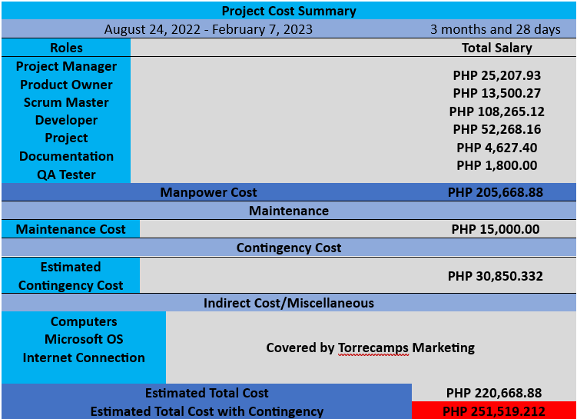

**Sponsor Acceptance**

Approved by the Project Sponsor:

Date:

<Project Sponsor Name>

### <Project Sponsor Title>

# Free Project Charter Template brought to you by [www.ProjectManagementDocs.com](http://www.ProjectManagementDocs.com)